Program No.: 01

**Aim:**

Installation of Python Software, Setting up environment variable path to Python software in a system, Demonstration of Sample python programs.

**Topics covered:**

Python installation and setup, basic structure of python program.

**Course Outcome**

CO1: Implement the basic concepts of Python.

**Steps in Installation and setup of environment variable path of python software**

* **Step 1:** Visit the link <https://www.python.org/downloads/> to download the latest release of Python. In this process, we will install Python 3.7 on our Windows operating system.

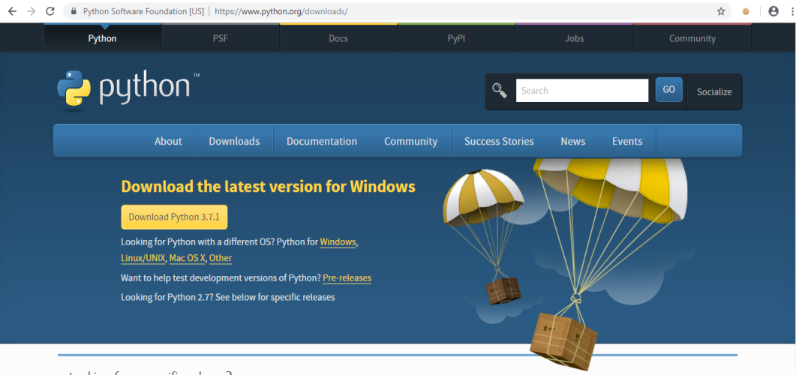

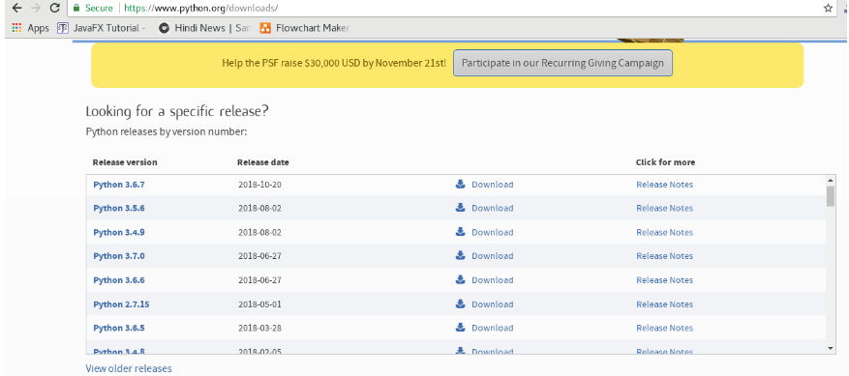

* **Step 2:** Double-click the executable file which is downloaded; the following window will open. Select Customize installation and proceed.

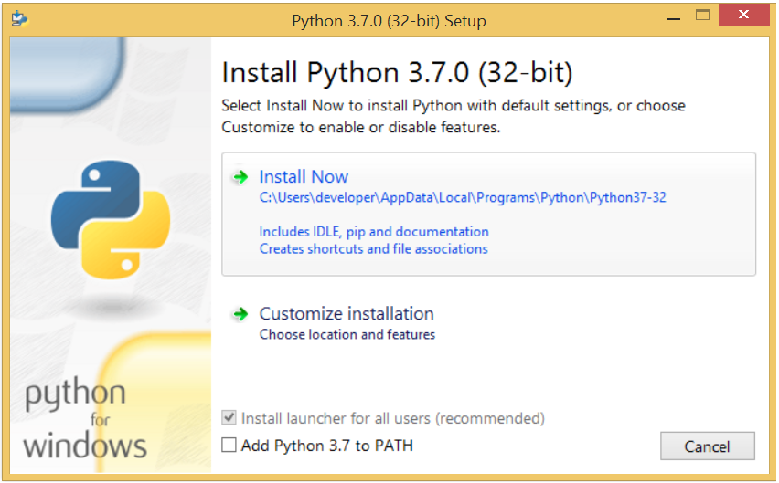

* **Step 3:** The following window shows all the optional features. All the features need to be installed and are checked by default; we need to click next to continue.

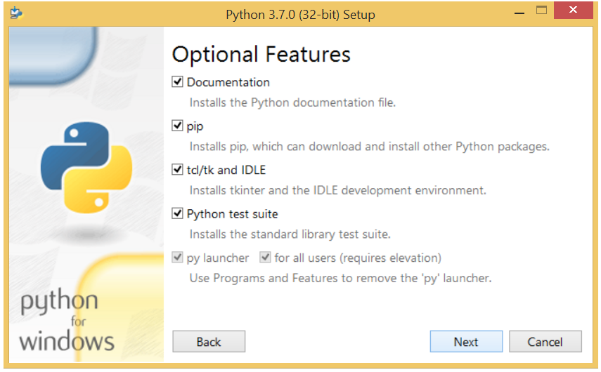

* **Step 4:** The following window shows a list of advanced options. Check all the options which you want to install and click next. Here, we must notice that the first check-box (install for all users) must be checked.

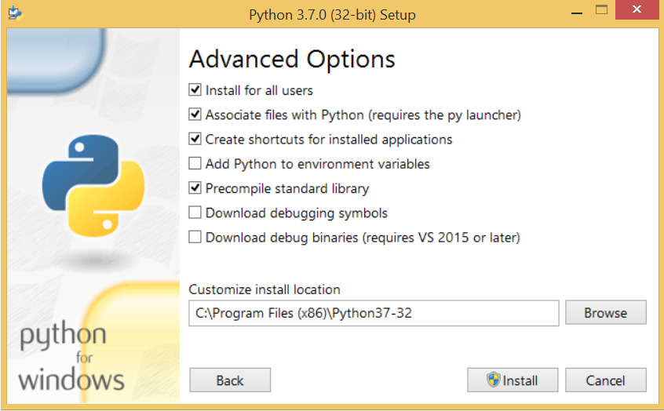

* **Step 5:** Now, we are ready to install python-3.7. Let's install it.

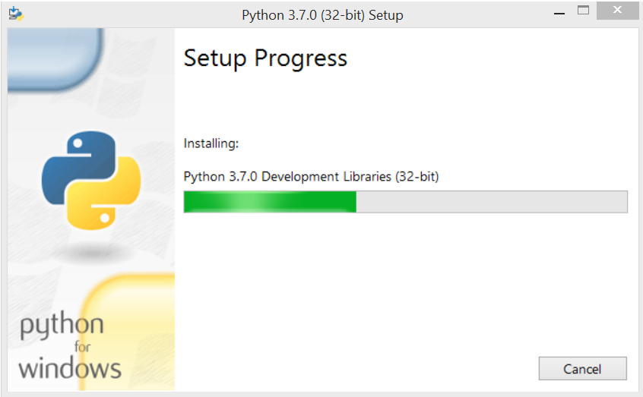

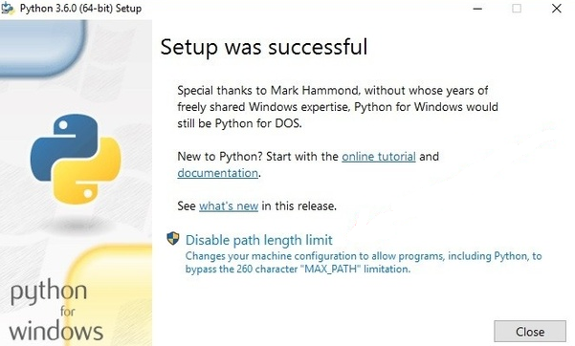

* Now, try to run python on the command prompt. Type the command python in case of python 2 or python3 in case of python 3. It will show an error as given in the below image. It is because we haven't set the path.

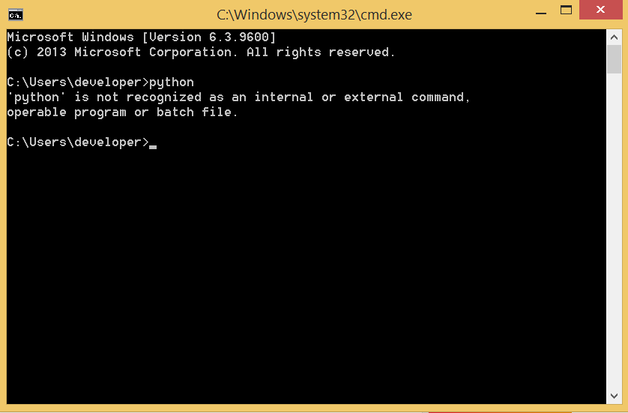

* To set the path of python, we need to the right click on "my computer" and go to Properties → Advanced → Environment Variables.

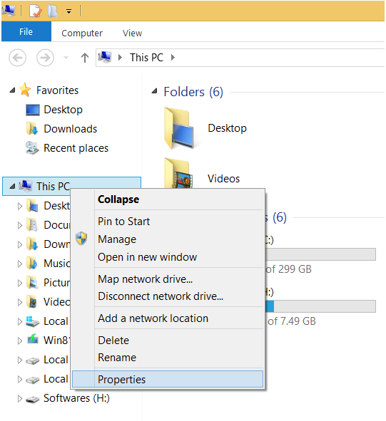

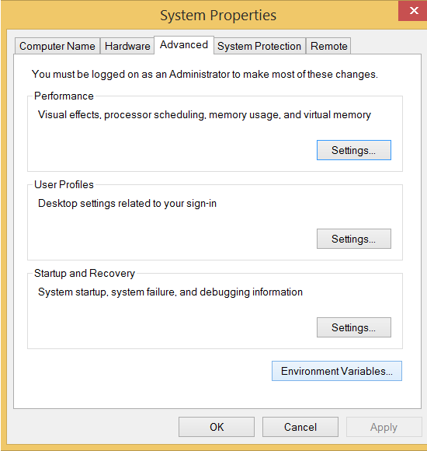

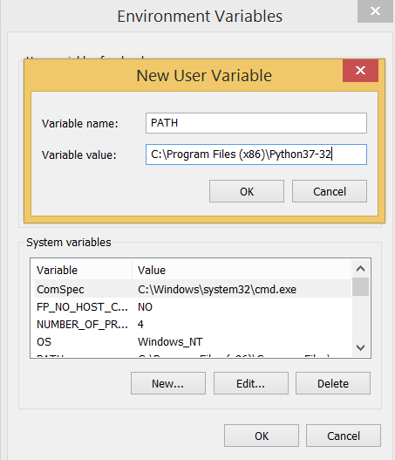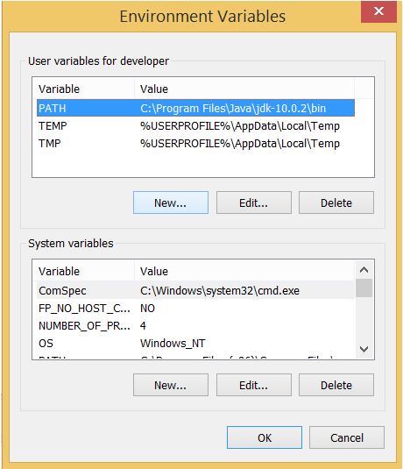

**Result:**

Installation of Python Software, Setting up environment variable path to Python software in a system done successfully.